

OUTLAND ADVENTURES

INFORMATION TECHNOLOGY REPORT



May 17, 2024

The SQLAR FEDERATION

123 ROUNHOUSE WAY – KANSAS CITY KS

# Who are we?

I am delighted to introduce The SQLar Federation, a distinguished consulting firm specializing in databases and comprehensive IT solutions. As a leader in our industry, our goal is to empower organizations through expertly managed technology services and data-driven strategies.

Our CEO, Mr. Edgar Rosales, is at the helm of The SQLar Federation. Mr. Rosales is a visionary with an exceptional track record for spearheading innovation and driving growth within the tech sector. His leadership is integral to the success and direction of our firm.

Our financial health and strategic planning are under the careful watch of CFO Ms. Melissa Lawrence. Her adept financial acumen ensures we deliver cost-effective and efficient solutions to our clients, emphasizing value and return on investment.

The technical vision and innovation of The SQLar Federation are shaped by our CTO and CIO, Ms. Sarah Ewing. Her dual expertise in technology and information systems equips us to offer cutting-edge solutions that are both practical and scalable, tailored to the unique challenges our clients face.

Adding to the strength of our executive team is CSO Mr. Emmanuel Diaz. His role is critical in defining comprehensive security strategies and ensuring the integrity and protection of our client’s data and IT infrastructures. His experience and foresight in cybersecurity are invaluable assets in today's digital landscape.

The SQLar Federation offers a suite of services that include database optimization, cloud computing solutions, big data analytics, and custom software development. Our team of seasoned consultants is dedicated to addressing the most daunting IT challenges with solutions that are both innovative and aligned with our client's business goals.

# Description of Case Study

"Outland Adventures" is a venture by Blythe Timmerson and Jim Ford, offering guided hiking and camping trips. They have a team handling trip planning, marketing, supplies, and an e-commerce site. The business model also includes an option for customers to rent or buy equipment. Recently, they've expanded their digital presence by developing an e-commerce site for information dissemination and online purchases. They're now considering business optimization, questioning the profitability of equipment sales, booking trends in the trek locations, and the age of their inventory.

# ERD

The diagram below shows the relationship between the different tables for the database we have built for Outland Adventures. Using all company information provided by Mr. Timmerson, we put this relational database together to maintain the company's business data better.

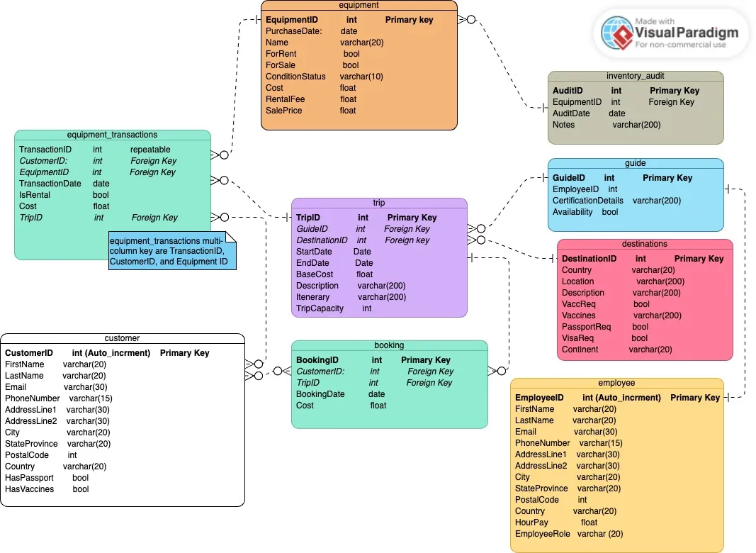

# REPORTS

# Question 1: Is the volume of equipment customers purchase sufficient to sustain the equipment sales segment of the business?

## Equipment Sales Sustainability:

|  |  |
| --- | --- |
| OUTDOOR EQUIPMENT REPORT | |
| Total equipment sales | 4 |
| Total items available for sales | 26 |

|  |  |
| --- | --- |
| Total take from Rentals | $2,403.00 |
| Total take from Purchase | $430.00 |
| Total take from equipment transactions | $2,833.00 |
| Total take from booking | $25,400.00 |
| Average profit per Purchase | $107.50 |
| Profit margin | 53.35% |

To assess the sustainability of the equipment sales segment, we propose conducting a detailed analysis of sales volume and profitability. By examining historical sales data and profit margins, we can determine if the current volume of equipment purchased by customers is sufficient to sustain this business segment. Additionally, we will evaluate customer feedback to identify opportunities for product diversification and targeted promotions to enhance sales.

Question 1 Continue:

|  |  |  |
| --- | --- | --- |
| Income Sources | | |
| Income Type | Income from type | Percentage of Total |
| Rental | $2,403.00 | 8.51% |
| Purchase | $430.00 | 1.52% |
| Booking | $25,400.00 | 89.97% |

# Question 2: Among the locations where trips are conducted - Africa, Asia, and Southern Europe -is there any location experiencing a decline in booking rates?

## Booking Rate Declines by Location:

To address the concern of declining booking rates in specific locations, we will conduct a thorough analysis of booking trends across Africa, Asia, and Southern Europe. By comparing historical booking data and identifying any recent declines, we can pinpoint the locations experiencing a downturn in booking rates. With this information, we will develop targeted marketing strategies, seasonal promotions, and potential partnerships to revitalize bookings in these areas and ensure sustained business growth.

|  |  |  |
| --- | --- | --- |
| Continent | Country | Total Bookings |
| Asia | Vietnam | 2 |
| Asia | Malaysia | 2 |
| Asia | Thailand | 2 |
| Africa | South Africa | 1 |
| Europe | Albania | 4 |
| Europe | Portugal | 1 |

# Question 3: Are there any items in the inventory that have been in stock for more than five years, considering equipment degradation over time?

## Inventory Aging and Equipment Degradation:

To mitigate the risk of equipment degradation and obsolescence, we will conduct a comprehensive inventory assessment to identify items in stock for more than five years. By categorizing inventory items based on age and condition, we can prioritize the clearance or replacement of older items to maintain quality standards and optimize inventory turnover. Additionally, we will implement regular quality assurance checks to ensure that all equipment meets safety standards and provides customers with high-quality products for their outdoor adventures.

Inventory items over five years old: 2

|  |  |  |
| --- | --- | --- |
| ID | Item | Date |
| 25 | Kayak | 6/1/2018 |
| 26 | Kayak | 5/10/2015 |

# Conclusion

To close, the comprehensive analysis provided in this report by The SQLar Federation offers valuable insights and strategic recommendations to optimize the operations of Outland Adventures. By addressing critical questions regarding equipment sales sustainability, booking rate declines, and inventory aging, we aim to empower Blythe Timmerson and Jim Ford to make informed decisions that drive business growth and enhance customer satisfaction.

Our team remains committed to delivering innovative solutions and leveraging data-driven strategies to support the success of Outland Adventures. We look forward to partnering with Blythe, Jim, and their team to implement these recommendations, fostering continued success and prosperity in the outdoor adventure market.

Please do not hesitate to contact us if you have any further inquiries or require additional assistance. Thank you for entrusting The SQLar Federation with your business optimization needs.

# Assumptions made for Project

* A single guide manages each trip.
* Multiple trips can concurrently be in the pre-trip planning phase.
* Trip bookings are accepted up to 2 months in advance or until the trip reaches capacity.
* Customers can cancel their trip bookings no later than two weeks before the trip date.
* A cancellation fee of 20% is applied if a customer cancels a booked trip.
* In the event of a trip cancellation by Outland Adventures, customers are entitled to a full refund.
* All equipment sales are final, no refunds.
* The business operates cash-only. (No money laundering activities are occurring.)
* Customers must sign indemnity clause documents.